Lab-11 List

1. Write a Python program to sum all the items in a list.

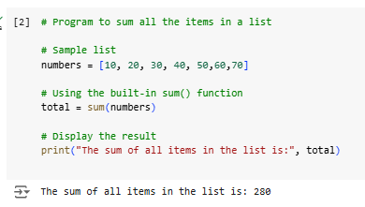

1. Write a Python program to get the largest and smallest number from a list without built-in functions.

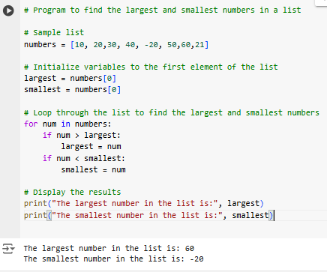

1. Write a Python program to find duplicate values from a list and display those.

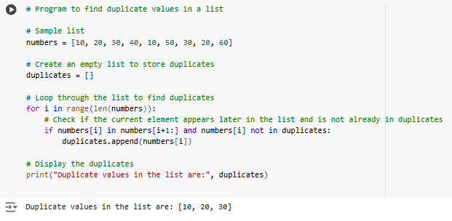

1. Write a Python program to split a given list into two parts where the length of the first part of the list is given. Original list: [1, 1, 2, 3, 4, 4, 5, 1]

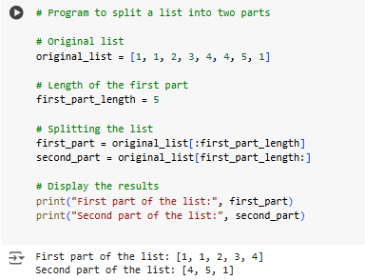

1. Write a Python program to traverse a given list in reverse order, and print the elements with the original index. Original list: ['red', 'green', 'white', 'black']

